Day 3

30 November 2023

10:04

**DAY's Agenda**

**Sharing Rules/Manual Sharing**

11. Share All **Customer** with Mr. Rajesh<<**Helpdesk user**>> which are created by admin

**Field History Tracking**

12. All Changes on **Customer** should be tracked.

**Assignment Rules**

13. Case assignment should be as follows: -

* + If Priority is High->**High Priority Queue**
  + IF Priority is low->**Low Priority Queue**

**Escalation Rules**

14. Cases should be dealt as per below: -

* + High Priority Cases should be closed in 2 Hours otherwise assigned to Admin
  + Low priority cases should be closed in 4 Hours otherwise assigned to Admin

**Approval process (Done with auto submission)**

15. All Reservations should be sent for approval first and once approved then status of Reservation should be set as approved where number of guests > 15.

**11. Share All Customer with Mr. Rajesh<<Helpdesk user>> which are created by admin**

**Requirements By The Client -**

You are the admin, **all the records which you created** should be **visible/editable** to the **user Rajesh**.

**Approach -**

**Solution - we have created 2 public groups in one public group we have added admin and in other public group we have added mr rajesh.**

**First we have to make sure that owd is private**

**Users -> profile -> helpdesk user -> Custom Object Permissions - all permissions should be removed**

**Sharing settings**

**Justification -**

**12. All Changes on Customer should be tracked.**

**Requirements By The Client -**

Customer Object is a **very important object**, if **any changes in the records**, we should have be **able to see the previous data .**

**Approach -**

**Solution -**first we have to enable the track field history from customer object details.

then go to field and relationship and select history tracking for all the fields.

And go to page layout-->related list, select customer history and drag for both customer layout and non-marketing page layout.

We can see old record of the customer object what was updated last time.   
 **Justification -**

**13. Case assignment should be as follows: -**

* + **If Priority is High->High Priority Queue**
  + **IF Priority is low->Low Priority Queue**

**Requirements By The Client -**

There are set of employees **who can handle high priority cases**, and there are other set of people **who can handle all the low priority cases**. And **all this people should be owner** of the cases.

All the cases should be **assigned automatically** to these people **based on priority**.

**Approach -**

**Solution -**first we have to create 2 queue as high priority queue and low priority queue and go to case assignment rule->new case assignment and add rule entity ,if case priority equals to high then assign the queue to high priority queue and if case priority equals to low then assign the queue to low priority queue. Then go to case object, priority is high and make sure that assign using active assignment rule should be checked. **Justification -**

**14. Cases should be dealt as per below: -**

* + **High Priority Cases should be closed in 2 Hours otherwise assigned to Admin**
  + **Low priority cases should be closed in 4 Hours otherwise assigned to Admin**

**Requirements By The Client -**

If a high priority case is **not resolved within 2 hours** it should be **transferred to admin**.

If a low priority case is **not resolved within 4 hours**  it should be **transferred to admin.**

**Approach -**

**Solution -  
create a new escalation rule and in that  
  
  
  
Justification -**

**Approval process (Done with auto submission)**

**15. All Reservations should be sent for approval first and once approved then status of Reservation should be set as approved where number of guests > 15.  
  
Changes -- > Only the approval process greater than 15 to be sent to approval.**

**Requirements By The Client -**

No matter what, **all the reservation should be sent to approval**, this should happen **automatically** and not manually.

If **approved** and the **total number of guest is greater than 15**, only then **change the status as Approved**.

**Approach -**

First thing whenever reservation is created it should be sent to approve automatically , we can do this using flows.  
  
Before that we need to have approval process through which we will submit, so we will create approval process.  
  
 *But*After approving if No of Guests is greater than 15 then change the status to approved otherwise don't.  
  
By this we can understand we will have to create two approval processes one that handles *Greater Than 15* other *Less Than or Equal 15.*In greater than 15 we should have filed update action to update Status field. Other we shouldn't.

**Solution -**

|  |  |
| --- | --- |
|  |  |

//Ambarish Document the solution  
 **Justification -**

// Give Justification To This approach, why flows and why not apex class , etc

we can solve by declarative i.e flows so we are not using apex. If we are not able to solve it by declarative approaches then we should use Coding(apex).

Explain Ratings and Resource

First explain how many record type we have before going to scenarios.

--which time zone we are using to set time?  
**GMT+ 5:30 - IST**

--Set Message as : The reservation cannot be in past.

**The reservation Date and Time cannot be in the past.**

--Please make correction in email alert(make it as 'Created') and Change in Mail body message. - Done

--Make Changes in page layout(add two columns). - Done

--Difference between ISBLANK() AND ISEMPTY().

--Make changes in when status is inactive. Use ISNEW() and ISPICKVAL() [use case 3].

3. Status for **Customer** cannot be inactive while creating new record.

|  |
| --- |
| **AND( ISNEW() ,ISPICKVAL(Status__c, 'Inactive'))** |

--Make '<=' in use case 2. -- done

2. **Reservation** time can't be in past.

--select 'created' for use cases 4 and 5. -- done

**4. If no status entered while Customer creation, Assign status as active for Customer.**

**5. Send email to ‘Customer email’ on Reservation creation: -> we have to perform 2 actions.**

**a. Customer Email field update on Reservation from Customer Email Field**

**b. Email Alert**

-- Search for the alternative approach for use case 6.

**Apex but its not declarative. So Combination of process builder and**

-- use case 9: Which one we have to choose [created or (created or updated)]? -

9). If Status of **Customer** is Active set source as direct (using record triggered)

**created and updated, because as per requirement for non marketing record type its always active - it should be direct**

* 1. ISBLANK:
     + ISBLANK() is used to check whether a field **has a value or not.**
     + It returns TRUE if the field is blank (empty or null), and FALSE if the field has a value.  
       Example:  
       **for white space -> it returns false**  
         
         
       ISBLANK(Your_Field__c)

* 1. ISEMPTY:
     + ISEMPTY() is primarily used with text fields to check if the text is empty or consists only of whitespace characters.
     + It returns TRUE if the text is empty or contains only spaces, and FALSE if the text has any non-space characters.  
       Example:  
       **For white space - ISEmpty returns true**  
       ISEMPTY(Text_Field__c)   
       Note: ISEMPTY() is not commonly used with fields other than text fields.

**Changes made as per use case requirement :**

1st use case - validation rules on Customer object

|  |  |
| --- | --- |
| Rule Name | Email_field_validation |
| Error | Condition Formula ISBLANK( Email__c ) |
| Error Message | Please Enter Email Id |

_____________________________________________________________________________

2nd use Case - validation rules on Reservation object

|  |  |
| --- | --- |
| Rule Name | Reservation_Date_time_validation |
| Error Condition Formula | Reservation_Date_Time__c <= DATETIMEVALUE( NOW()) |
| Error Message | Reservation Time cant be in the Past |

_____________________________________________________________________________

3rd use Case - validation rules on Customer object

|  |  |
| --- | --- |
| Rule Name | inactive_status_validation_rule |
| Error Condition Formula | AND(ISPICKVAL(Status__c, 'Inactive'),ISNEW()) |
| Error Message | Status cant be inactive |

_____________________________________________________________________________

4th use Case - workflow Rules

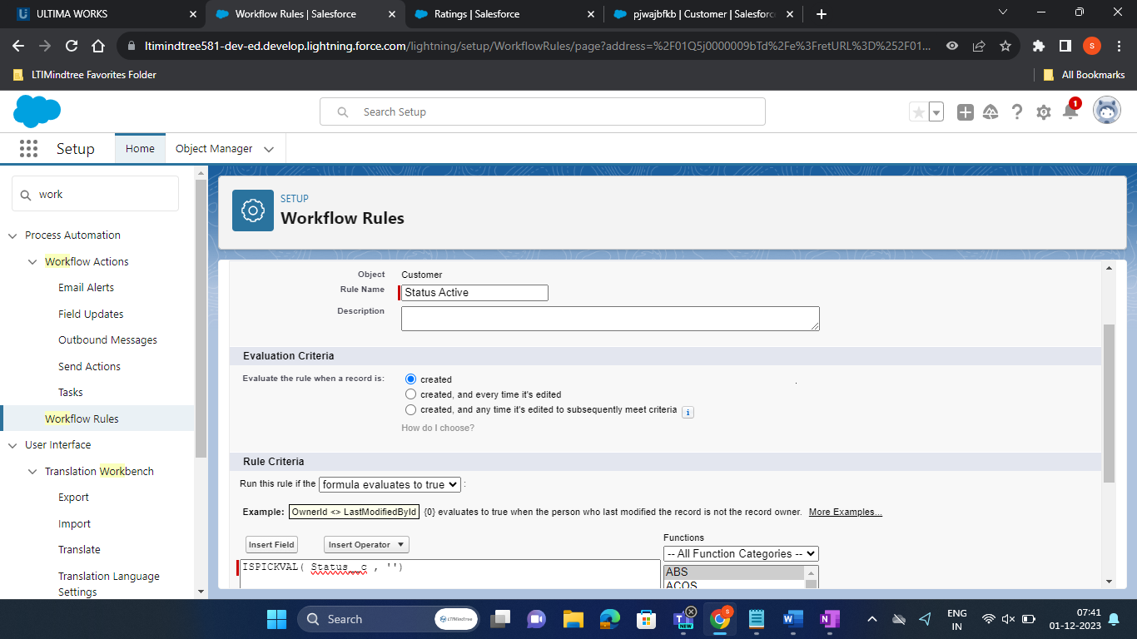

_____________________________________________________________________________

5th use case -



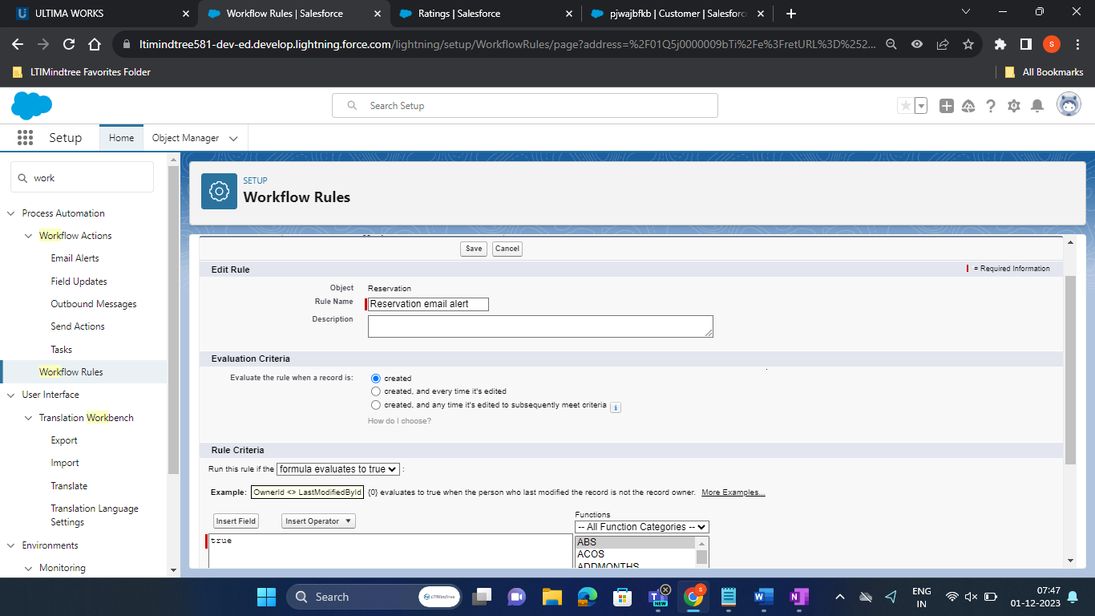

__________________________________________________________________________________________________

1. Email Alert

Hello {!Reservation__c.Customer__c},

Hope this message reach you. Your Reservation Is created and sent for approval, we will notify you once approved.

Thanks,

RMS

